CARD 1
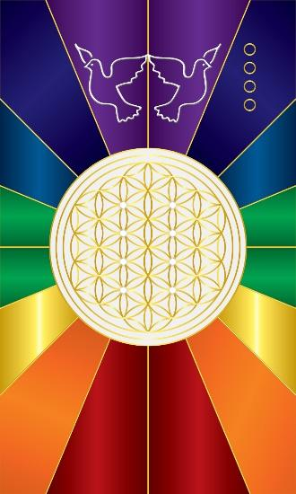
For this card I wanted to convey the impulse of the creative energy and the creator. We now have a defined white circle which separates the subjective and objective realms. The subjective realm is inside the circle from which creation manifests. The objective realm is outside the circle. We are using light as a metaphor to convey that the white within the circle, representing unity, is manifested as the many colors outside the circle, yet the many comes from the one source. The white circle represents the white cloth and Obatala as chief of the white cloth indicates unity. A cloth is made up of the fabric which binds it together so the white cloth represents the “substance” or fabric that binds the universe. The fabric or structure of this substance is represented by the golden flower of life pattern within the white circle.

White represents purity and calmness, and thus peace. The dove is one of the symbols of Obatala because it is the symbol for peace and tranquility. As creator, Obatala is also said to mold humans from clay. Last, the lattice structure embeds Ogbe Meji.

In addition to the above elements, there is an underlying structure embedded in the design of the cards, and we can point this out starting with card 1. At the top, notice that the colors are that of fire or flame being red orange and yellow. It indicates Heat, activity, expansion, Yang, etc. At the bottom we have the cool colors, which indicates rest, contraction, and water. At the top the doves are separating, flying away from each other, and at the bottom they are coming together or contracting. You will notice that the “constellation symbols” at the top all correspond to the Fire or Air element. (Active, light, expansive) If they are at the bottom, they will correspond to the Water or Earth element. (Inactive, heavy, contractive). Depending on how one divines, the structure can be utilized by the diviner. In Card 2 & 4, Jupiter is related to this energy and rules Sagittarius and Pisces. Note that Sagittarius is a Fire sign at the top, and Pisces is a Water sign at the bottom. Similar to these, Card 5 has Aries (Fire) at the top and Scorpio (Water) at the bottom, and Card 6 Leo (Fire) at the top and its counterpart Card 9 Cancer (Water) at the bottom. The Air and Earth cards (3, 7, 8) are similarly structured.

Comments by Baba Awodele

